IS 350—Professor Mark G. Simkin The Kitchen Timer

Objective: The objective of this assignment is to create a simple VB application that mimics the operation of a kitchen timer. This assignment requires a good understanding of data types, Visual Basic variables, If instructions, string manipulations, and the Timer control.

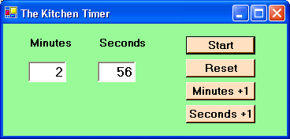

Description: The kitchen timer works like a chronograph. When the user clicks on the Start button, the system timer begins working and for each passing second, the number of seconds displayed decreases by one unit. After displaying “0” for the seconds, the system subtracts one unit from the minutes remaining (if one or more minutes remain) and displays “59” for the seconds. The user can reset the system’s values to “0” by pressing the “Reset” button. If the user clicks on the “Minutes +1” button, the system increases the number of minutes remaining by one unit. If the user clicks on the “Seconds +1” button, the system increases the number of seconds remaining by one unit. When both the minutes and seconds are “0,” the system should continue to display “0’s” and beep repeatedly to alert the user that the time is up.

Hints: (1) A suggested user interface is as shown. (2) Use the Timer control set to an interval of “1000” to count down the seconds, and the Timer’s Tick event to execute code. (3) The Beep instruction causes Visual Basic to beep once.

Deliverables: Screen-capture the application’s interface at run time and also print a copy of your code. Test your program with the following timer settings: (1) 30 seconds, (2) 1 minute and 10 seconds, and (3) 2 minutes and 15 seconds. However, it is only necessary to hand in one screen capture for this problem.

